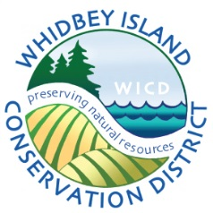 Whidbey Island Conservation District
P.O. Box 490 – 404 NE Center Street - Coupeville, WA 98239 - 360.678.4708 - Fax: 360.678.2271
________________________________________________________________________
AGENDA
Whidbey Island Conservation District Board Meeting (6.21.15 DRAFT)

DATE: June 25, 2015
TIME: 9:00 a.m. – 11:00 a.m.
PLACE: 1 NE 4th Street Coupeville, WA 98239

9:00 a.m. WELCOME
- Establishment of a quorum/ Introductions
- Approve and sign May 28, 2015 meeting minutes/ACTION

9:05 a.m. FINANCIAL REPORT – Sandy Welch / ACTION
WSCC Master Contract signatures / ACTION
Year-end projects and funding

9:25 a.m. NRCS report

9:35 a.m. WSCC Report and State Funding – Shana Joy, WSCC Puget Sound Regional Manager

9:45 a.m. Cost share policy for FY16 / ACTION

9:55 a.m. FY15 Cost Share Projects – Ken Drecksel and Rob Hallbauer / ACTION

10:05 a.m. Farm Plan Presentation 6_15-1 –Ken Drecksel / ACTION

10:20 a.m. Staff Reports
- Ebey’s 2 Project update/ Element Soln. contract – Rob Hallbauer (10 min)
- Website stats – Sarah Cassatt (10 min)
- District Manager Report – Karen Bishop (15 min)
  - DOE agreement
  - FY16 projects
    - Grant applications – BMP manual, Coupeville Schools rainwater catchment project
    - Other project opportunities – ILIO, Russell Foundation
  - Puget Sound Districts update
  - WADE

10:55 a.m. Other, Review of Motions and Adjourn

Upcoming dates:

Board Meeting - July 23, WICD office, 9:00 – 11:00 a.m.

