WICD Recognizes Award Winners at Annual Open House
Whidbey Island Conservation District cooperators and partners were recognized at an open house held on April 8 at the Coupeville Library.
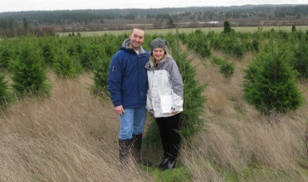
The Outstanding Cooperator award went to Patricia & Mike Miller. Over the last two years, the Millers have been restoring a former Christmas tree farm north of Oak Harbor, adding a few livestock, an orchard, a large garden, and a rainwater collection system. Theirs is an exemplary small-scale production farm working in concert with natural resource conservation.
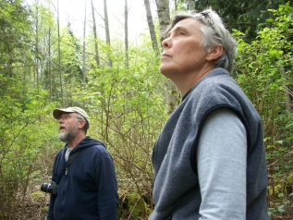
The Everell “Duke” LeBaron Land Steward award went to Anza Muenchow & Marc Wilson for their management of their farm and forest. Anza and Marc attended the Forest Stewardship Coached Planning Class in Coupeville in 2012. Since then, they have been implementing their forest conservation plan, obtaining EQIP cost-share funding from NRCS to improve their forest’s health through thinning. This year they are installing a high-tunnel to expand their fruit and flower production. They use and teach natural sustainable methods for local food production.
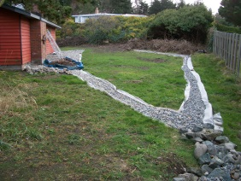
The Outstanding Homeowner award went to Robert Mackie. With the design help from Whidbey CD, Robert installed an alternative stormwater system to alleviate flooding in his home’s crawlspace. The system intercepts and diverts stormwater to a rain garden in his yard, reducing downstream impacts and beautifying his yard.

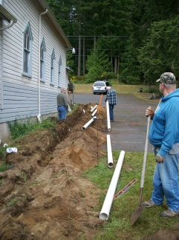
The Deer Lagoon Grange was the recipient of this year’s Outstanding Partner award. The Grange has hosted many classes open to the public about farming and using local foods. Chris Williams and Claire Acord, in specific, are responsible for the Grange Food & Farm News newsletter and blog, which announces classes and events related to farms and food and connects local producers and consumers. The Grange also has installed an alternative stormwater management system, including two rain gardens, to protect the foundation of their historic building.

The Outstanding Supporter Award went to Stu Trefry, the Regional Manager for the ten Northwest WA Conservation Districts for the Washington Conservation Commission. Stu helped guide the WICD through the process to develop a more stable funding base which allows us to help all residents and landowners of Whidbey Island. Stu not only provides guidance to District managers but also to the District’s Board of Supervisors, who are themselves residents and landowners of Whidbey Island and essential to providing local control.
All award winners were presented with a plaque honoring their achievements.

